| **Test Name** | | Add Error Type to System | | | |
| --- | --- | --- | --- | --- | --- |
| **Use Case Tested:** | | Use Case - Add Error Type to System | | | |
| **Test Description:** | | User needs to add a new error type  User navigates to Manage Error Types tab.  User is presented with a blank form to add the new error type details.  User enters the required information  User submits form | | | |
| **Pre-conditions** | | Error must not exist in the system | | | |
| **Post-conditions** | | The database is successfully updated with the new data for the Error Type. | | | |
| **Notes:** | |  | | | |
| **Result (Pass/Fail/Warning/Incomplete)** | |  | | | |
|  | **TEST STEP** | | **EXPECTED TEST RESULTS** | P | F |
|  | User selects “Search > Manage Error Types” from the menu bar or selects Manage Error Types button on Admin Home page | | A blank Error Types Details form appears – using Button  A blank Error Types Details form appears – using Menu Bar | X  X |  |
|  | User enters the Error Type | | Input does not show error | X |  |
|  | User selects Submit button | | Message appears that the record was successfully added | X |  |
|  |  | | Database updated to show new error type | X |  |

|  |  |  |  |  |  |
| --- | --- | --- | --- | --- | --- |
| **Test Data Table** | | | | | |
|  | **1** | **2** | **3** | **4** | **5** |
| Test – 1 | Another Error Type |  |  |  |  |
| Test – |  |  |  |  |  |
| Test – |  |  |  |  |  |
|  |  |  |  |  |  |

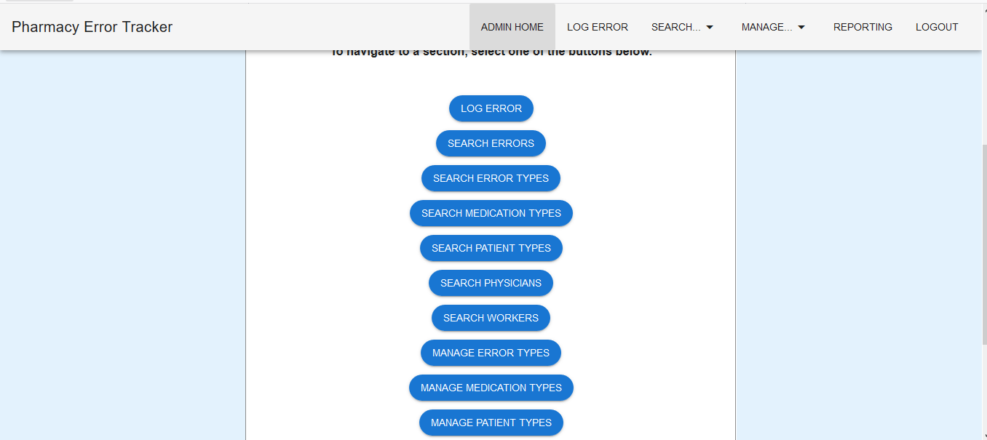

Figure 1: Select Manage Error Types via Button

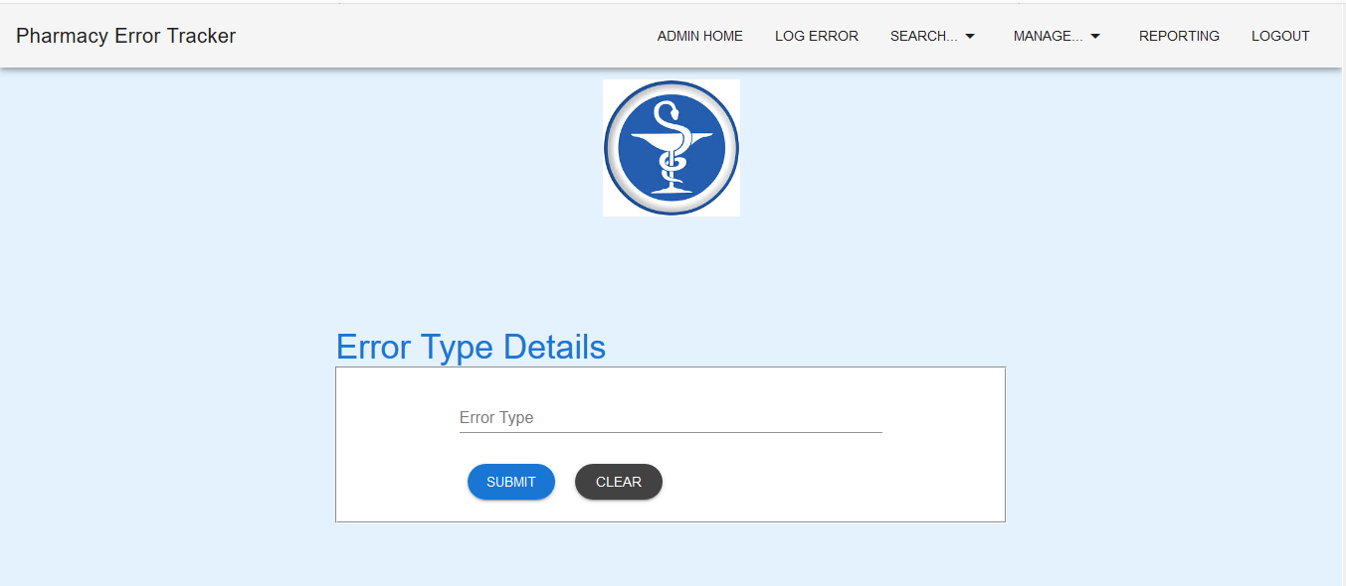

Figure 2: Error Type Details form is loaded

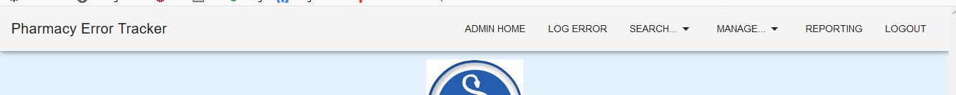

Figure 3: Select Manage Error Types via Menu Bar



Figure 4: Error Type Details form is loaded

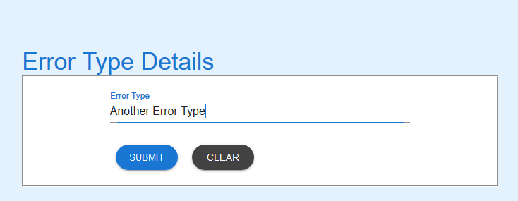

Figure 5: Details entered

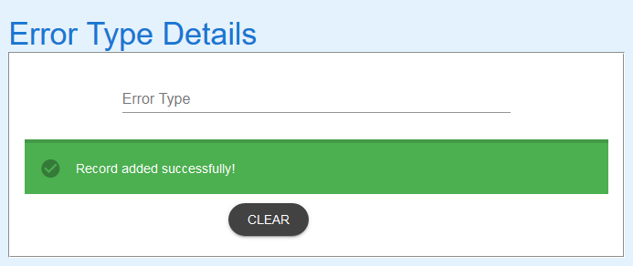

Figure 6: Submit button selected. Success message returned

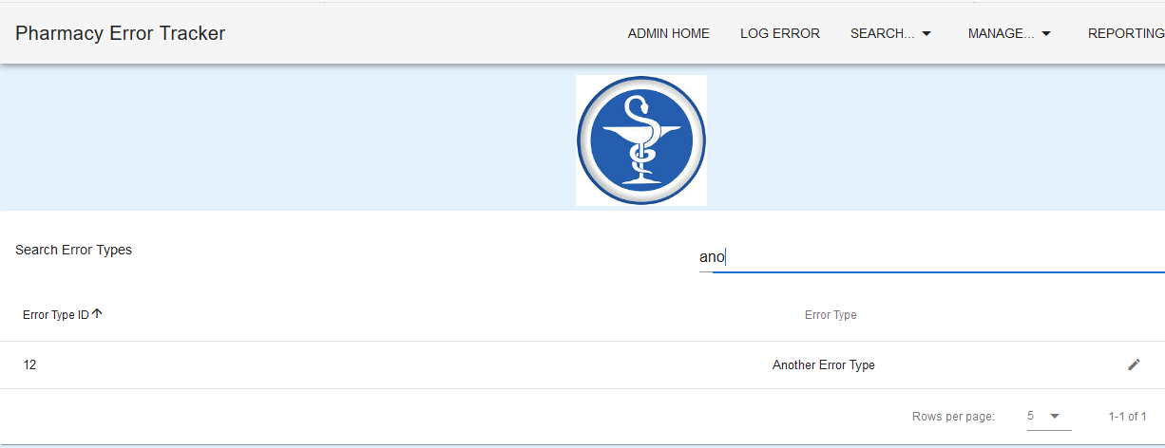

Figure 7: Search for "ano" shows the new error type has been added to the database

EXPECTED ERRORS:

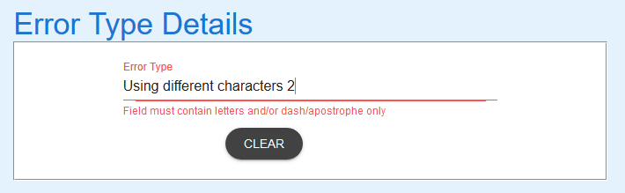

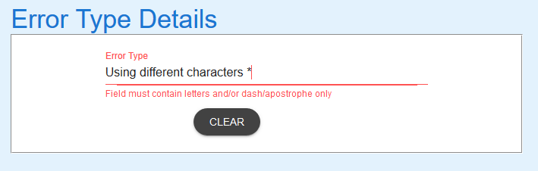

Figure 8: Adding a number or character other than – or ‘ to description causes error – Expected

EXPECTED BEHAVIOUR  
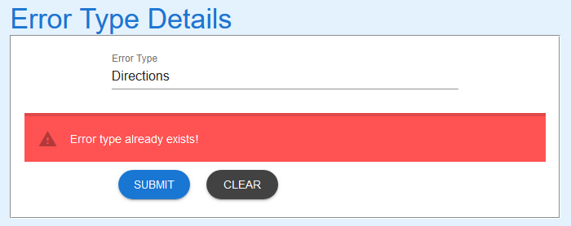

Figure 9: Adding an Error Type that exists causes an error message to appear - Expected

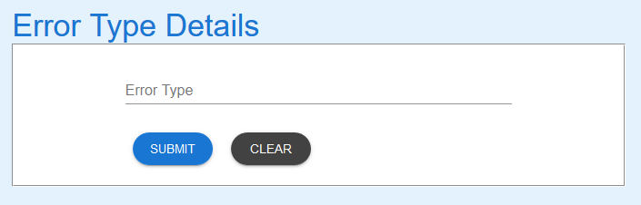

Figure 10: Selecting Clear resets the form - Expected